**Identify Common Characters in two strings**

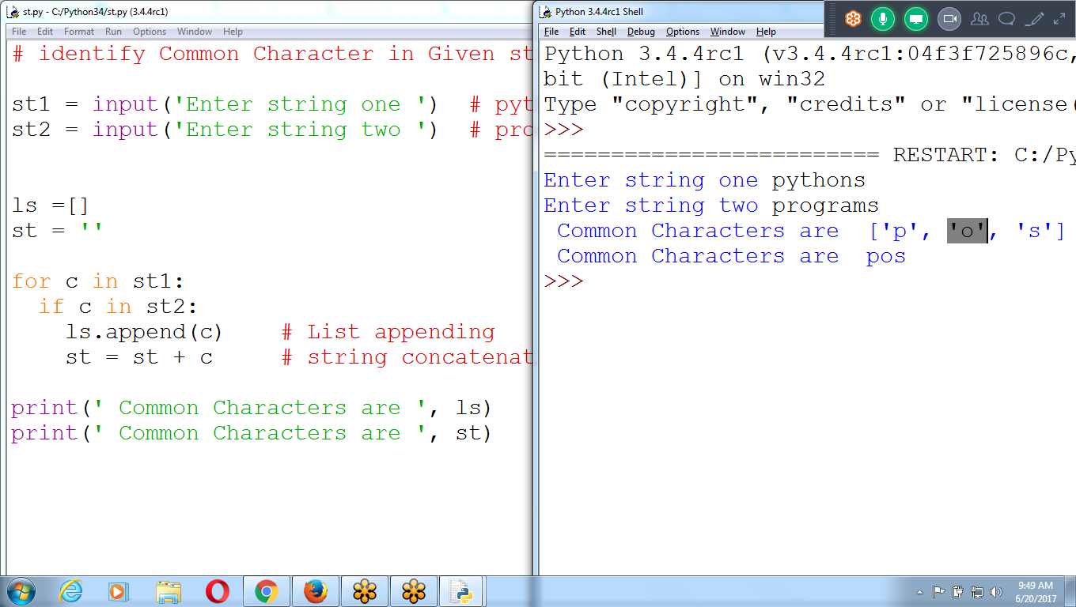

# identify Common Character in Given strings

st1 = input('Enter string one ') # pythons

st2 = input('Enter string two ') # programs

ls =[]

st = ''

for c in st1:

if c in st2:

ls.append(c) # List appending

st = st + c # string concatenation

print(' Common Characters are ', ls)

print(' Common Characters are ', st)

**Arranging Strings in LIST Type**

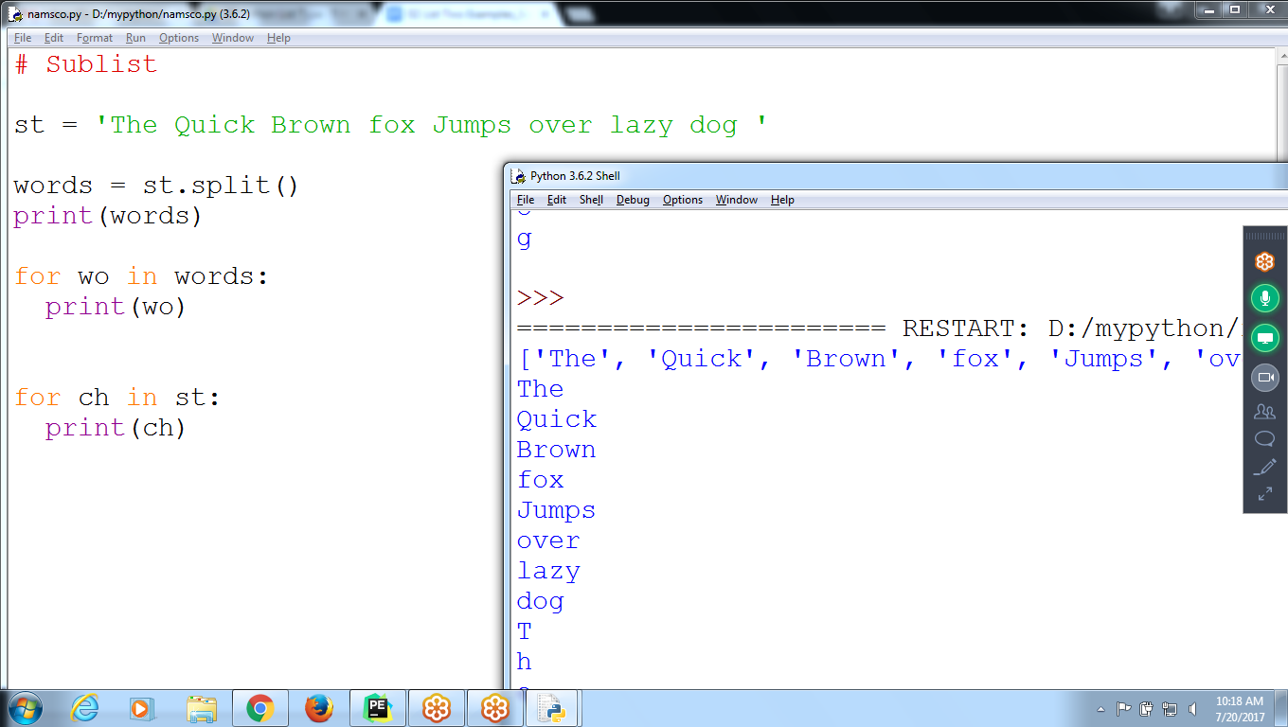

**# Sublist**

**st = 'The Quick Brown fox Jumps over lazy dog '**

**words = st.split()**

**print(words)**

**for wo in words:**

**print(wo)**

**for ch in st:**

**print(ch)**

**A list of lists: nested list**

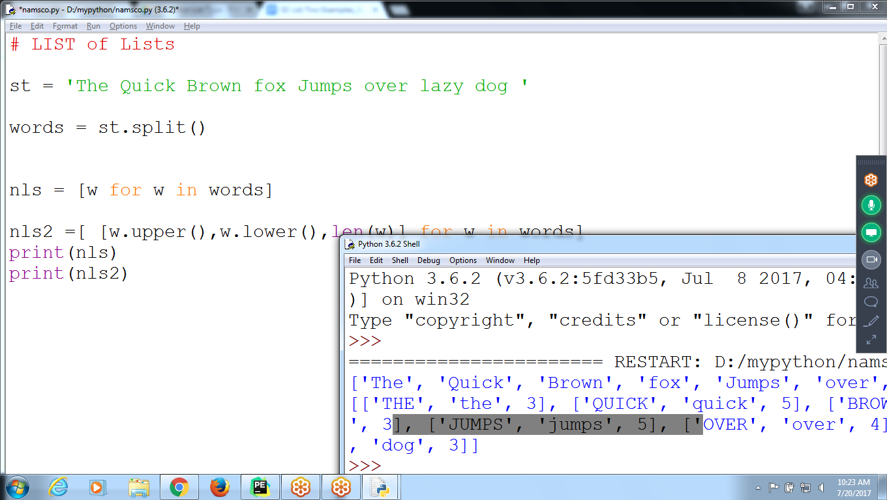

# LIST of Lists

st = 'The Quick Brown fox Jumps over lazy dog '

words = st.split()

nls = [w for w in words]

nls2 =[ [w.upper(),w.lower(),len(w)] for w in words]

print(nls)

print(nls2)

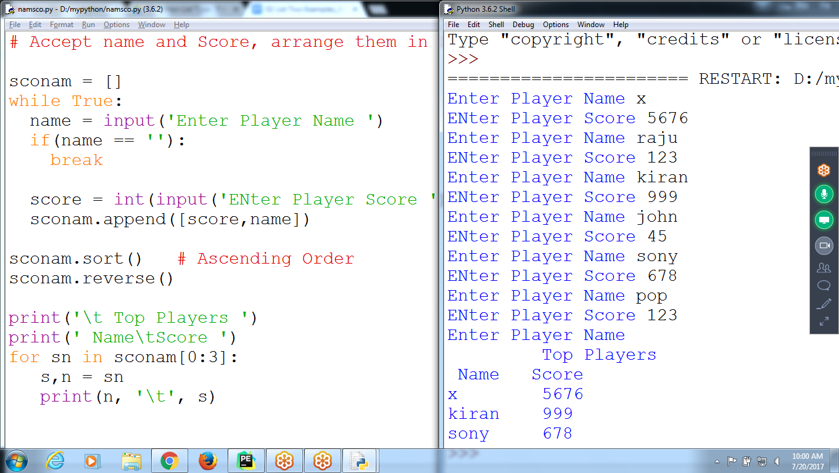

List of Sublist

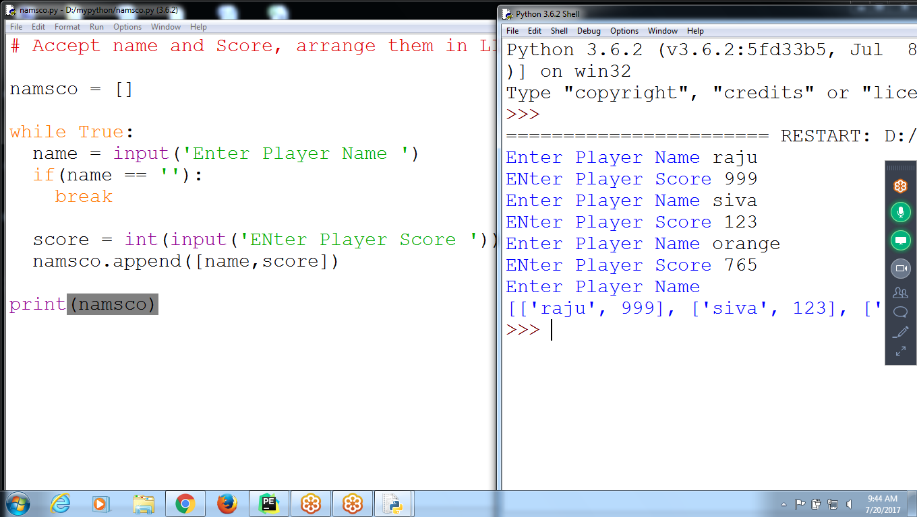

# Accept name and Score, arrange them in LIST

namsco = []

while True:

name = input('Enter Player Name ')

if(name == ''):

break

score = int(input('ENter Player Score '))

**namsco.append([name,score])**

print(namsco)

**Sort(), Reverse :: Using List and Sublist**



**# Accept name and Score, arrange them in LIST**

sconam = []

while True:

name = input('Enter Player Name ')

if(name == ''):

break

score = int(input('ENter Player Score '))

**sconam.append([score,name])**

sconam.sort() # Ascending Order on score basis

**sconam.reverse()**

print('\t Top Players ')

print(' Name\tScore ')

for sn in sconam[0:3]:

**s,n = sn**

**print(n, '\t', s)**

Asdfgf ;lkjhj asdfgf ;lkjhj

Qwertr poiuyu qwertr poiuyu

Zxcvc .,mnbn zxcvc .,mnbn

Abcdefghijklmnopqrstuvwxyz

**TYPING**

**asdfgf ;lkjhj asdfgf ;lkjhj**

**qwertr poiuyu qwertr poiuyu**

**zxcvc zxcvc .,mnbn .,mnbn**

**abcdefghijklmnopqrstuvwxyz**

**python**

**program**

**language**

**ram**

**NESTED LIST :**

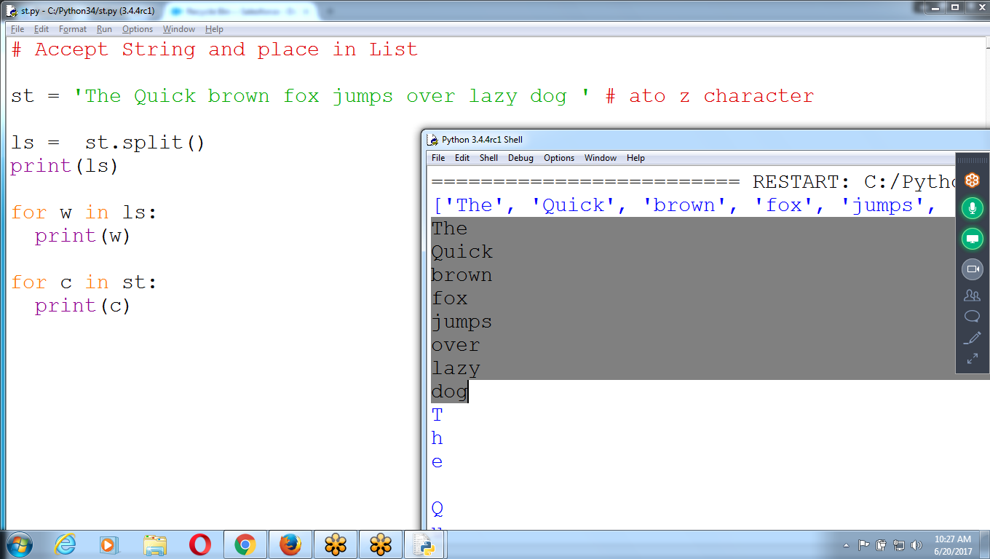

**# Accept String and place in List**

**st = 'The Quick brown fox jumps over lazy dog ' # ato z character**

**ls = st.split()**

**print(ls)**

**for w in ls:**

**print(w)**

**for c in st:**

**print(c)**

***********************************************************************************************************************************************************************************************************************************************************************************************